#GivingTuesday 2020
Background
Coming on the heels of Thanksgiving, Black Friday and Cyber Monday, the worldwide charitable campaign of #GivingTuesday falls on Dec. 1 this year. People across the globe embrace this day of giving in the height of consumerism around the holidays. They day reminds people to give back in a meaningful way rather than getting caught up in shopping days like Black Friday and Cyber Monday. On this day, people throughout the world make the commitment to support a charity through the gift of time, donations, or goods. Since its start in 2012, #GivingTuesday has grown year after year with $300 million donated online during the day last year.

How You Can Participate
Think of Giving Tuesday as a way to jump-start the “spirit of stewardship” at your parish. Most parishioners know the importance of tithing but not all of them are aware of the many ways in which to do so. Yes, it’s important to give financially to your parish for building maintenance, community missions, and more. But what about giving of your time or your talents? Can you devote an hour per week to cut the grass? Teach a youth religion class or make phone calls?
The primary way people engage and give on #GivingTuesday is online. Utilize the hashtag #GivingTuesday on social media, your website, and email to encourage people to participate.
By setting up multiple ways for people to give and volunteer digitally, you’re better connected whether your parishioners are at home or traveling for the holidays.

Sample Bulletin Announcement
As Catholics we are called to receive God’s gifts gratefully and share them lovingly with one another. December 1st we will join in the celebration of Giving Tuesday, a global day of kindness and generosity. In this time of uncertainty, there's a fundamental truth that can give us hope – that together we can do extraordinary things.
You can show your generosity in a variety of ways during Giving Tuesday—whether it’s donating funds, participating in a new ministry, volunteering, or praying, every act of generosity and kindness counts! Join us online, as we gather together to raise funds, support our parishes and ministries, and share our faith on Giving Tuesday! >>parish website url<<
Sample Facebook Posts
Save the date: #GivingTuesday is Tuesday, Dec. 1. You can be part of the celebration by giving to your favorite Catholic nonprofit (which we know is us!) Find out more >>parish website url<<

We gave thanks on Thanksgiving, shopped on Black Friday and Cyber Monday, now we're ready to give on #GivingTuesday - are you? Save the date to kick off the season of giving: Tuesday, December 1. >>parish website url<<
Sample Graphics
Instagram:
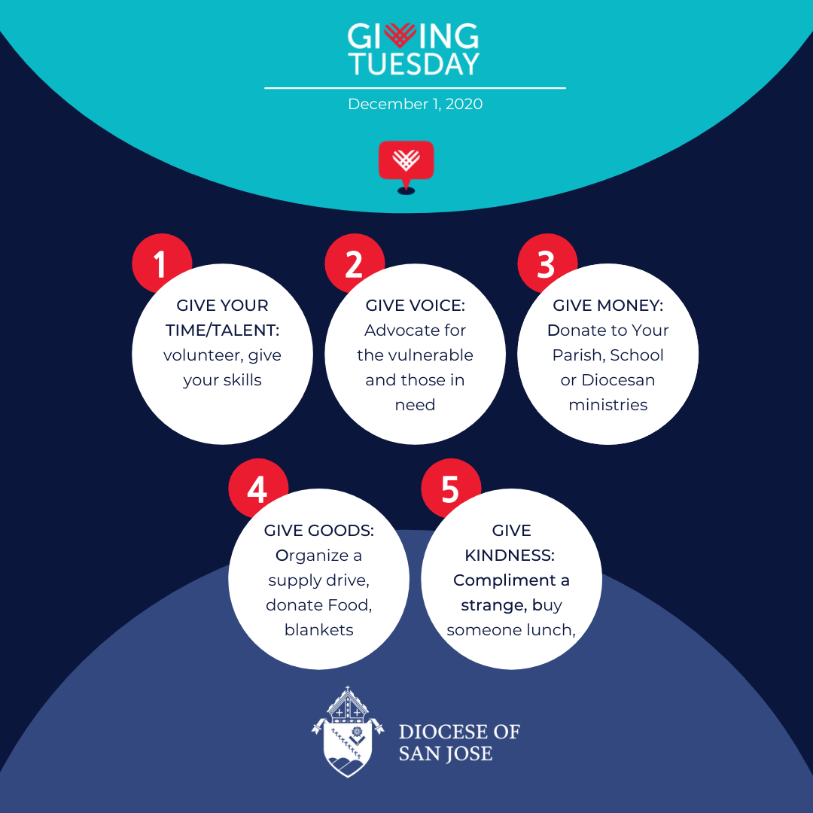
Twitter/Facebook: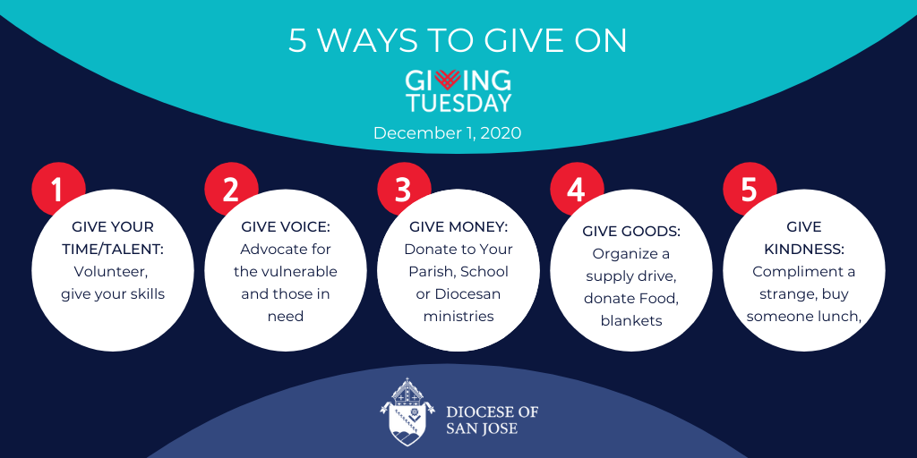
Instagram:
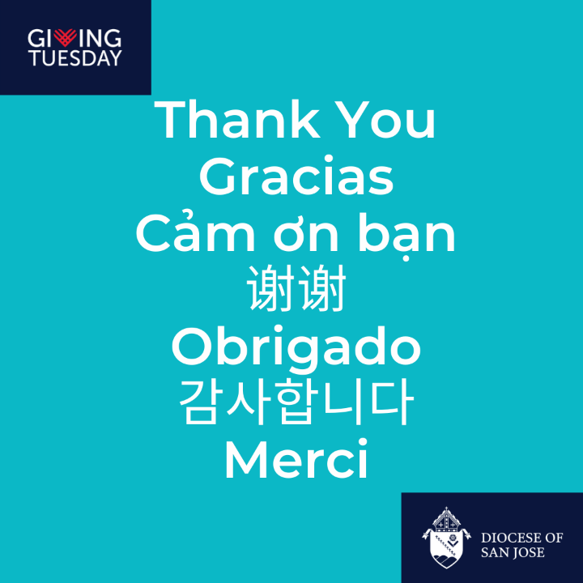
Twitter/Facebook:
