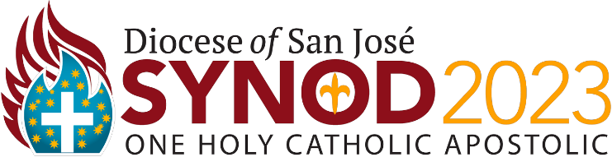
Parish or School Consultation Session Summary Worksheet

- Type all the ideas or recommendations from your consultation session’s flip charts for each question into this worksheet.
- Replace the bullets below with the ones from your parish or school.
- Keep it simple. One line or one sentence for each recommendation.
- Email your completed worksheet to communications@dsj.org within seven days of your session.
Parish or School Name: Click or tap here to enter text.
Number of Participants in Session: Click or tap here to enter text.
ONE - What changes should be implemented so that our clergy, school leaders, staff (parish, school and chancery), lay leaders, members of the faithful and school families operate more collaboratively across all parishes and schools?
- Click or tap here to

- enter text.
HOLY - What can our parishes and schools do to INSPIRE all members of the parish and school communities to desire an intimate relationship with Jesus Christ?
- Click or tap here to

- enter text.
HOLY - What ministries and resources must each parish and school have in order to routinely FORM disciples of Jesus Christ?
- Click or tap here to

- enter text.
CATHOLIC - What ministries and resources must our local parishes and schools explore to increase positive encounters with, learning from and appreciation of the diversity in our Catholic community?
- Click or tap here to

- enter text.
APOSTOLIC – What ministries and resources must our parishes and schools implement to most effectively reach out to: a) youth, young adults, and young families; b) those who no longer worship in our parishes; and c) the disenfranchised?
- Click or tap here to

- enter text.
APOSTOLIC – What ministries and resources must our parishes and schools implement to: (a) form and activate the faithful and school families in living Catholic Social Teachings; and (b) collaborate with other parishes and schools to serve those in need?
- Click or tap here to

- enter text.

